Arizona State Cowbelles  Membership  Application | 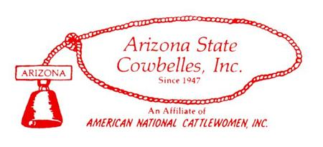
Print and complete this form.
mail this form along with your check payable to:

Arizona State Cowbelles

Membership Chair
c/o Jolene Miller, Treasurer
P O Box 1053
Yarnell, AZ 85362
Please indicate the membership type below:

Individual Membership Options

_____ $25 Arizona State Cowbelles, Inc. Membership
_____ $375 Arizona State Lifetime Member (must be a member in good standing for 10 years)
_____ $15 for Collegiate and Junior Members for Arizona State Cowbelle Membership
_____ $50 Affiliation Dues to ASC
_____ $60 American National CattleWomen, Inc. Basic Membership (Oct. 1, 2015)
_____ $1,000 American National CattleWomen, Inc. Lifetime Member (increased in 2014)
_____ $20 Collegiate and Junior Members for American National CattleWomen
_____ $85 Sustaining Member for American National CattleWomen ($60 dues plus donation)
__ __ $10 Subscription Fee for Newsletters, etc. – Golden Girls (65+ years) No Charge
_____ $ 250.00 Affiliate Dues to ANCW
_____ $100 Associate Members - Business, Corporations, or Private Enterprise

Please indicate if you are: ___ ____ Renewal _______ New Member _______ Associate

CHECK # _________ AMOUNT $____________ CASH __________ DATE _EVERY YEAR___

- Extra Donation:
- _____ ASC Cowbelles
- _____ Event/Activity/Committee
- _____ Other ________________________________________________________________

Name: ______________________ _________________________________________________
Mailing Address: _______________________________________________________________
City, State, Zip: ________________________________________________________________
Phone: ___________________________ Fax: ______________________________________
Cell Phone: ___________________________ E-mail: _________________________________

Are you currently an AZ State Cowbelle? ____________ ANCW Member? _____________

- We welcome women interested in supporting the beef cattle industry through consumer awareness, education and the promotion of nutritious beef.
- The ASC is the longest standing cattle women nonprofit membership organization.
- We offer leadership development, education, volunteer opportunities and friendship.
- We are affiliated with the American National CattleWomen, Inc.

